Final Analysis Report
Name
Affiliation
Date

Apple Inc has played a major role to revolutionize the world in terms of technological advances. Global activities in the world are being undertaken with much ease (Benjamin, 2007). The first computer, the Apple I, has undergone evolutions to the present day iPhones and PCs. Despite the many challenges that it faces, Apple Incorporation remains unshaken and standing to ensure computer technology is always and ever evolving. The question of how Apple Inc has always maintained top ranks in the technology market is a mystery to be resolve. Hence, in the event of answering this status quo, this paper seeks discuss analytically the competitive strategies employed by Apple inc. using the Five Forces Model approach. The paper will also tend to provide feasible recommendations which can be applied to make Apple Inc more competitive.
Five Forces Model approach Analysis of Apple Inc competitive strategies
Threat from rivals
Apple was the first company to come up with the first “personal” computer that could be easily used. However, IBM pioneered bringing PCs into the mainstream market as early as in the 1980s. In the early 1990s, a new wave swept through the computer development world shaking developments and interfering with the market. A new product dubbed “wintel” gained entry into the market with a storm occupying the larger proportion of the market share. Manufacturers of “wintel” used an Intel processor that ran on the windows OS. The growth of these emerging products was propelled by the decreased prices these products sold at. The world was also on a transition and more and more computerization of premises was taking place. New markets had been discovered in the Asian front comprising China and the Middle East. A number exceeding one billion PCs were in use the world over by 2010.
PCs were developed that had greater capabilities such as increased storage memory and faster processing speeds. However, the growth of revenue did not move in direct proportionality. PC average selling prices were on the decline at an approximately 8 percent annual rate decline between 1999 and 2000. The various individual components of the PC dropped even further. Central processing units, hard disks, memories and the various drives were dropping at a rate of averagely 30% annually. Profits from the manufacture of PCs gradually declined with their profit margins falling below 5%. PC components were also standardized. This minimized the need to plough more money into innovation and research. China, Japan and Taiwan became the new hub for contract manufacturing which became a necessity to enable computer manufacturers to stay afloat.
As advancements are being made, competition between computer companies is growing steeper day by day. Companies are coming up with technologically advanced devices every day. This rapid development says John et al (2009) is pushed by the urge of a company to stay ahead of the business. The struggle between these companies is likely not to come to an end. Apple, from the past has always had stiff competition and at other times it could no put up with it. On the hardware development front, Apple faces steep competition from hardware developers such as Dell, Lenovo, HP, Compaq, to name but a few. The software market is also flooded. The major competitors in the software front comprising mainly windows. Windows has occupied the bigger share of the market since its entry into the market. Manufacturers of fancy music players such as Sony and Samsung are also a threat to the music players created by Apple. To stay afloat, Apple Inc has constantly been formulating strategies and implementing effective tactics of beating the competitors.
Threats from new entrants into the market
The market niche occupied by Apple Inc is associated with many small upcoming companies. The companies are located in other areas other than the US. These are potential markets for the products of Apple Inc. Countries like China and Japan harbor companies that have acquired licenses from rivals of Apple Incorporation.
These companies have invented cheap clones of the latest developments in technology with anticipation of forcing their way into the market. This is a substantial problem for Apple Inc and other companies. However, due to the cheap prices and short durability of the clones, many customers incline more toward purchasing expensive but quality products from Apple Inc. Comparatively, over the recent past, Apple inc. has been able to make substantial sales that have seen it through as a market leader.
To ensure dominance of the market rank, Apple Inc conducts a lot of advertisement and promotion. This strategy has proven practicable due to the recorded increasing rates of customers. Apple Inc also offers customer free services to ensure maximum customer satisfaction.
Competition from substitute products
The cell phone industry front is not a bed for roses for Apple Inc. There has been stiff competition ever since Steve Jobs penetrated that sector. Players like Nokia and Samsung have posed the greatest competition to the iPhone which was just an ordinary communication tool by early 1990s. In order to brand it and stay ahead of the competition, other applications were integrated into the iPhone in the late 1990s. This pushed Apple to occupy the first rank with more that 60 percent of the market in the industry (John et al 2009). Problems also arose from network operators who collaborated with phone manufacturers and promoted the sale of certain brands of phones.
In 2008, Apple designed the second iPhone which pushed it ahead in terms of market share. It brought about a 30% increase from zero. Other companies handsets were selling at an average of 300$ and 400$. Apple was making about 562$ out of selling the iPhones.
In the phone industry Apple faced competition in terms of the models. Companies had opted to develop smart phones with Nokia leading. To stay in the competition, Apple came up with the iPad in 2010. The iPad was a stylistic product containing features of both a mobile phone and a laptop. In the first week sales adding up to 450,000 were made from the new devices.
Alternative technologies such as TV set-top boxes and music players have the same functionality with some features of the PC. Various developments in the electronics world saw entry of advanced devices such as the play stations that integrated various functions such as watching movies, surfing the web and playing games. Various hand held devices have also emerged that also do some functions of the personal computer such as smart phones. These alternative technologies have had an impact on the development of the PC. However, PC developers such as Apple have strained to maintain the PC at the heart of the of the business shift.
Bargaining power of consumers
Suppliers of the components that make up these technological gadgets greatly affect the growth of Apple Inc. There are those who supply music, those that supply movies, the distributors of movies through television, manufacturers of television sets, suppliers of the Intel chips for manufacturing the various gadgets and computers. The higher the cost of supply, the more expensive Apple sells the items. Bargaining power of suppliers is a great determiner of how the prices swing.
Personal computers were the first product that Apple had over the counter. The consumers fell into distinct groups such as small scale consumers and large-scale consumers. There were those who needed the products for use in their homes, the small to medium sized businesses, corporations the education sector and the government. Half of the world-wide sales represented the home consumers. The various consumers looked for different things in the products they purchased. The home consumers considered the design, connectivity with wireless and mobility. Service and support was the concern for businesses while software availability worried the education consumers. Cost was also a factor that all the consumers considered, (Bach, 2007).
Several changes on the supply front were noted in the 1990s. People buying trend shifted from service dealers to direct products manufacturers. Big stores were the major suppliers of computers to the home users and the small business dealers.
Consumers of the various products produced by Apple inc. use the products differently. Music consumers mostly do not pay for music as they prefer to share the music via various tools in their small peer groups. Suppliers of music may choose to lower their prices to encourage sales. Corporations are the consumers of computers. They choose what to consume depending on how effective the computer is able to deliver. Other products such as the music players should be as affordable as any other music device in the market (Bach, 2007).
Bargaining power of suppliers
The PC industry also has suppliers. They are demarcated into two categories as follows; those that made products that could be bought from various other sources such as keyboards, drives and memory chips and those that made products which could only be bought from few other sources such as operating systems and processors. Microsoft and Intel were the main suppliers of the microprocessors’ and operating systems.
The microprocessor chips are the most important components of a computer. 80% of the PC market was dominated by Intel. Companies like Advanced Micro Devices and VIA technologies were major competitors to the Intel Company but still Intel maintained its competitive edge. The prices of the micro-chips dropped as the computers were dropping in cost by nearly 30% per annum.
An operating system is the combination of softwares that enabled a computer to run. Since the 1980s this market had been a reserve of Microsoft as the leading software developer. Exceeding 90% of the world’s computers used Microsoft as their OS. Microsoft XP entered the market in October 2001 taking the market by storm. It sold more than 17 copies at inception. They later introduced vista later in 2007 that never picked up well. Windows 7 came in handy to rescue the situation two years later. Windows 7 created history in being the fastest selling operating system in history.
Testing Hypothesis:
Null Hypothesis:
The increased profit margin in the apple company is not anywhere associated with the effective marketing strategies
Alternative Hypothesis:
This is different from the above in that it clearly states there the profit margin of the Apple Company is closely associated with the good associating with the marketing strategies.
- Theory/Model
The predictor variable which is also referred to as the independent variable can mainly be associated with the levels of sales, the level of competition in the market and the effective strategies when it comes to marketing. On the other hand depend variables is mainly concerned with the overall performance of the company. The information relating to this examination involves the part of advertising whereby the successful showcasing procedures are considered to cause generally improved execution in an organization.
- Data Source
The main source of data for this piece was clearly gotten from the apple official website (https://www.apple.com) and also the papers of business. The data collected will be enough to work out the regression analysis with the variables enlisted.
- Model Checkpoints
- Simple Linear Regression
As simple linear regression is being ran on the model the regression value for R-squared is 0.5949. R-squared is a value that clearly shows the close data on the chart that is to be fitted on the regression line (Faraway, 2016). R-squared is expected to be between 0 and 100% (Pardoe, 2010). In this case, the R-squared (0.5949) shows that the regression model explains the variability of the response data around the mean.

The standard error of estimate calculated in excel is 184.4561. This estimate shows the accuracy of the data presented in the regression. It measures the accuracy of the predicted variables on the regression line (Bates, Maechler, Bolker and Walker, 2014). From the output resulting from the regression analysis done on excel, the regression equation obtained is y = 0.4138x-4.8948.
In running this variable, first we did remove all "NOT Significant variables in the model, the output shown above. In regression output below: the Intercept is -3281.16 and the Slope is 626.22.
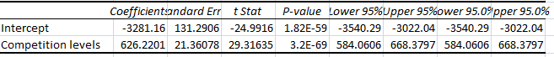
Therefore, the Regression Equation would be:
Competition levels = -3281.16 + 626.22(IMProvement Levels)
- Multiple Linear Regression
Applying the multiple linear regression in our model, we have the output shown below:
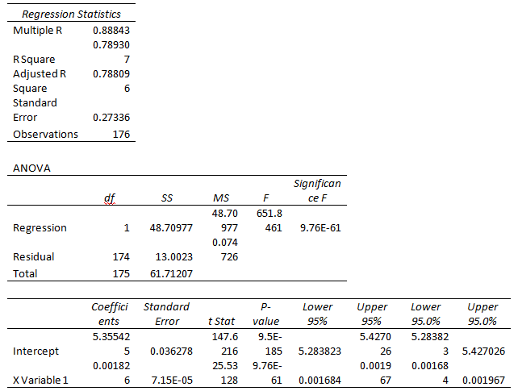
We noticed that all variables have p values that are less than to the value of f-test, hence we conclude that these variables contribute in explaining the variation of the production unit. Multiple linear regression with one or more dummy Independent Variables
SUMMARY OUTPUT
Regression Statistics
Multiple R | 0.001679718
R Square | 2.82145E-06
Adjusted R Square | -0.005744289
Standard Error | 123.0341059
Observations | 176
ANOVA
 | df | SS | MS | F | Significance F
Regression | 1 | 7.431466 | 7.431466 | 0.000491 | 0.982348
Residual | 174 | 2633906 | 15137.39
Total | 175 | 2633914
 | Coefficients | Standard Error | t Stat | P-value | Lower 95% | Upper 95% | Lower 95.0% | Upper 95.0%
Intercept | 61.83270366 | 16.32804 | 3.786903 | 0.00021 | 29.60619 | 94.05922 | 29.60619 | 94.05922
X Variable 1 | -0.000713058 | 0.032182 | -0.02216 | 0.982348 | -0.06423 | 0.062804 | -0.06423 | 0.062804

The predictions made using multiple regression are often more Informative than the predictions made using linear regression with one predictor variable.
- Multiple linear regression with a binary Dependent Variable (logic model)
In the model, we have the dichotomous dependent variable have two choices: Yes to high sales in each performances and No to high sales in each performance.
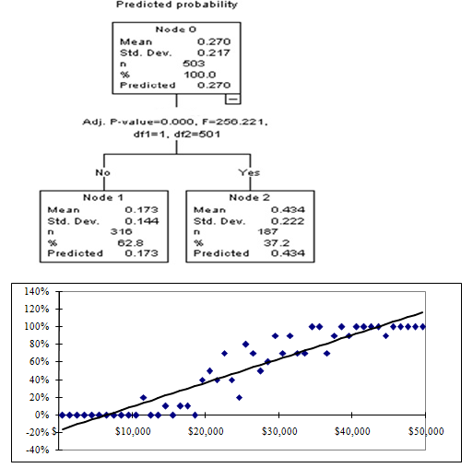
The dummy dependent variable is:
The key is the threshold value:
e <= threshold Yes: High sales
e > threshold No High sales
- Summary
- Lesson learned
I have so much learned in running this model with the application of regression. The regression coefficients ("betas") are effect sizes. In a simple linear regression, this is the slope of the regression line i.e. the change in the response variable when explanatory variable changes by one unit, in a different straight relapse, this is the slant of the (hyper-)plane toward the indicator. This implies: the estimation of beta reveals to you how much the anticipated worth changes when the comparing indicator is expanded by 1 unit, holding any remaining indicators consistent.
Recommendation
I recommend the application of simple linear regression in this model. This is because, simple linear regression, there is no affected variable, unlike to multiple linear regression which arises when there is one variable effected by many. Thus in statistical modeling variables helps in showing the various observation and it will throw the new attributes. This helps in designing the model on flexible rather than concentrating on limited on constrained level. Relapse is utilized to decide the degree to which to recognize a direct connection between a needy variable and sometimes at least one free factors. There are for the most part two kinds of straight relapse, straightforward direct relapse and numerous direct relapse. In first, basic straight relapse a solitary free factor is used to anticipate the estimation of a reliant variable.
This model focused on the overall performances where it indicates the marketing results and sales and strategies when it comes to marketing. With the above results using the regression analysis, assumed that the overall performance is the dependent variable for the regression output shown above and the significance level of 5%, the p value of the variable is less than 0.05, then the variable is significant for the model, therefore, the result is significant to this model. We also get positive slope to the IV as we remove the non-significant variables.

References
Apple, 2018, https://www.apple.com/. Accessed 20 Sept 2018.
Bates, D., Maechler, M., Bolker, B., & Walker, S. (2014). lme4: Linear mixed-effects models using Eigen and S4. R package version, 1(7), 1-23.
Faraway, J. J. (2016).Linear models with R. Chapman and Hall/CRC.
Pardoe, I. (2010). Applied regression modeling: A business approach. Hoboken, N.J: Wiley- Interscience.

